GPS Ballyannan Castle 51.89694. -8.16928
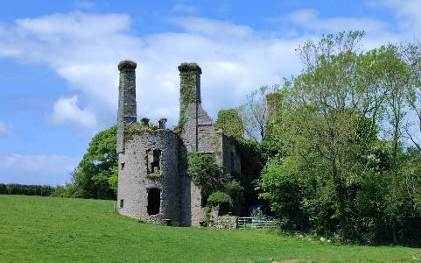
When coming from Midleton at the roundabout before joining the N25, take a left on the road to Ballyannan and Ballyvodock. The Ruin of Ballyannan House/Castle are on the right.
St John Brodrick’s first occupied the castle built in 1650, in 1786 it was already in ruins, in 1814 it was occupied by Roger Willians at the time of the Griffith Valuation’s it was valued at £9.10 occupied by Daniel Twomey held from Lord Midleton, to the left is a small tidal inlet, which once was a graveyard, just some years ago some bones were found , its also reported when ploughing an nearby field silver spoons were found, There is a cave running from the side of the Castle to Ahanesk

GPS Ballyvodock Castle 51 88781. -8.21161
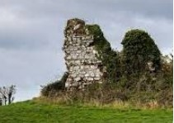
We take the road to Ballyvodock taking the turn for Ahanesk and cone to Ballyvodock Castle ruin, and nearby Ahanesk House, these townlands were part of the old Parish of Mogeesha, the Castle a 14th century ruin built by the Hodnett family to guard the entrance to the Great Island, which later fell under the control of the Barrys, it features a commanding position on a headland in Cork Harbour, with what remains near East Ferry

GPS Leamlara House. 51.96623. -8.26977
Leamlara House was located midway between Carrigtwohill village and Watergrasshill, In the late 1950’s the estate was sold to the Land Commission who divided it up and sold the land to farmers, the owner of this estate was Standish Barry at one time an MP. The main entrance was off the Leamlara road, there was a handsome set of gates and pillars and across the road a gate lodge built of cut limestone
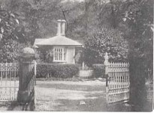
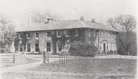
There were extensive lawns and gardens with a lake formed by the Leamlara river, at one time in the late 1800’s it was proposed to build a reservoir at this Lake to supply drinking water to the towns of Cobh and Midleton along with Carrigtwohill, however agreement could not be reached and the proposal was abandoned. An electricity generator was installed, powered by water from the lake which supplied DC current to the house. When the Estate was divided up the house was demolished
GPS B urial Ground Barret’s Field 51.92271 -8.30333
GPS Killacloyne Church 51.93506 -8.31762

